Minor Project Final Report on

**STUDY ROOM: e-learning QA Module**

Submitted in partial fulfillment of the requirements for the degree of

**Bachelors of Engineering in Information Technology**

under Pokhara University

Submitted by:

**Abhinav Paudel, 15449**

**Mandeep Panta, 15464**

**Ashbin Thapa, 15455**

Date:

28th April 2023

**Department of Information Technology**

**NEPAL COLLEGE OF**

**INFORMATION TECHNOLOGY**

Balkumari, Lalitpur, Nepal

**ABSTRACT**

*This project serves as a platform where developers can ask and answer technical questions related to programming, software development, and other technology-related topics.*

*The platform operates on a user-generated content model, where users can ask questions and provide answers. Users can also add comments, and participate in discussions on a wide range of technical topics. The platform hosts a vast collection of user-generated content, ranging from specific coding issues to broader software development concepts.*

*The projects serve to provide a platform for knowledge exchange, where developers can ask and answer technical questions related to programming, software development, and other technology-related topics. The platform aims to facilitate the exchange of knowledge and ideas, promote best practices, and help developers find solutions to technical challenges.*

*This project is based on Python and Django framework, Bootstrap, HTML and CSS. A website that allows a user to inquire about their problems about coding and many software programming related queries and post solutions to them.*

Keywords: Knowledge Exchange, Study materials, Study Platform

Contents

**1.** **INTRODUCTION** 1

1.1. PROBLEM STATEMENT 1

1.2. OBJECTIVES 1

1.3. PROJECT SCOPE AND LIMITATIONS 2

1.3.1. SCOPE 2

1.3.2. LIMITATIONS 3

1.4. SIGNIFICANCE OF STUDY 3

2.1. PREVIOUS SIMILAR WORKS 4

**3.** **METHODOLOGY** 6

3.1. SOFTWARE DEVELOPMENT LIFE CYCLE 6

3.1.1. REQUIREMENT PHASE 7

3.1.2. ANALYSIS AND DESIGN PHASE 7

3.1.3. IMPLEMENTATION 7

3.1.4. TESTING 7

3.1.5. EVALUATION 7

3.2. WHY ITERATIVE MODEL? 7

3.3. TOOLS USED 8

3.4. TECHNOLOGIES 8

**4.** **WORK DIVISION** 9

**5.** **PROJECT DELIVERABLES** 10

**6.** **PROJECT TASK AND TIME SCHEDULE** 11

6.1. GANTT CHART 12

**7.** **REQUIREMENT ANALYSIS** 13

7.1. FUNCTIONAL REQUIREMENTS 13

7.2. NON-FUNCTIONAL REQUIREMENTS 14

7.3. INPUT REQUIREMENTS 15

7.4. OUTPUT REQUIREMENTS 15

7.5. SECURITY REQUIREMENTS 15

**8.** **SYSTEM DESIGN AND UML DIAGRAM** 16

8.1. SYSTEM ARCHITECTURE 16

8.2. ER DIAGRAM 17

8.3. USE CASE DIAGRAM 18

8.4. CLASS DIAGRAM 18

8.5. DATA FLOW DIAGRAM 19

8.6. CONTEXT DIAGRAM 20

8.7. SEQUENCE DIAGRAM 20

8.7.1. SEQUENCE DIAGRAM FOR REGISTER 21

8.7.2. SEQUENCE DIAGRAM FOR LOGIN 21

8.7.3. SEQUENCE DIAGRAM FOR LOGOUT 22

8.7.4. SEQUENCE DIAGRAM FOR EVENT 22

**9.** **PROJECT TESTING** 23

**10.** **CONCLUSION AND FUTURE WORKS** 26

**11.** **REFERENCE** 27

**12.** **APPENDIX** 28

Screenshots of developed systems 28

**LIST OF TABLES**

Table 1: Tools used 8

Table 2: Work Divisions 9

Table 3: Project Task and Time Schedule 11

Table 4: Functional Requirement 13

Table 5: Non-Functional Requirement 14

Table 6: Project Testing Table 23

**LIST OF FIGURES**

Figure 1: Iterative model of software development life cycle 6

Figure 2: Gantt Chart 12

Figure 3: System Architecture 16

Figure 4: ER Diagram 17

Figure 5: Use Case Diagram 18

Figure 6: Class Diagram 19

Figure 7: Data flow Diagram 19

Figure 8: Context Diagram 20

Figure 9: Sequence Diagram for Register 21

Figure 10: Sequence Diagram for Login 21

Figure 11: Sequence Diagram for Logout 22

Figure 12: Sequence Diagram for Event 22

# 

# **INTRODUCTION**

Study Room is a question and answers website for programmers. This web application will be the platform where developers can ask and answer technical questions related to programming, software development, and other technology-related topics.

The platform operates on a user-generated content model, where users can ask questions and provide answers. Users can also add comments, and participate in discussions on a wide range of technical topics. The platform hosts a vast collection of user-generated content, ranging from specific coding issues to broader software development concepts.

## PROBLEM STATEMENT

Study Room is a website that hosts a community of programmers and developers who ask and answer questions about programming-related topics. As such, a problem statement for Study Room would be:

"How can I solve a specific programming issue or error that I am encountering in my code? I am seeking help from the Study Room community to find a solution or a better way to approach my problem."

The problem statement should include details about the specific issue or error, the programming language or technology being used, and any relevant code or examples to help others understand the problem. Additionally, it should convey a willingness to learn and a desire to collaborate with others in finding a solution.

## OBJECTIVES

The drawbacks mentioned in problem statements need to be solved, for which a new and easier method for a learning needs to be derived. Study Room : e-learning class module is such an web application where the users can present their queries and receive answers from the others users. Following are the objectives of this project:

1. To develop web application for asking and answering the questions related to various faculties.
2. Help to build learning community.
3. Develop an interactive web application with user friendly search interface.
4. To allow people to communicate to increase flow of information among them.

The drawbacks mentioned in problem statement needs to be solved, for which a new and easier method for taking appointment is needed to be derived. The main objective of a doctor appointment and recommendation system is to improve patient outcomes by providing personalized recommendations for healthcare providers. Doctor Appointment and Recommendation System is a web application where the patient can book their appointments with their preferred doctors. Similarly, this web application recommends the best doctors for the treatment of the patients as well. Following are the objectives of this project:

1. Enhancing patient satisfaction by providing recommendations of doctors,
2. Provides the searching facilities based on various factors such as Doctor, Patient, Booking, Doctor Schedule,
3. Tracks all the information of Appointment and Booking,
4. To increase efficiency of managing the Doctor and Patient,
5. Integration of all records of Doctor Schedule.

## PROJECT SCOPE AND LIMITATIONS

The scope of this project is to provide user with all the services through a web service. In this project, a web application will be developed where users will be able to ask and answer questions.

### SCOPE

1. The targeted people are programmers and developers.
2. This web application can be modified and used for various college/school or even universities.

### LIMITATIONS

1. This is only website not a app.
2. This web application is mainly focus to developers.

## SIGNIFICANCE OF STUDY

This project is proposed with the intention to develop a Web Application of the QA platform where users can ask the questions of their concern and obtain answers from other users. The existing platform provides the QA platform however this project will have some additional features regarding the study materials and chat feature. So, this project is meant for providing user friendly web application in efficient way.

1. **LITERATURE REVIEW**

## PREVIOUS SIMILAR WORKS

**Quora** is a Q&A platform that empowers people to share and grow the world’s knowledge. People come to Quora to ask questions about any subject, read high quality knowledge that's personalized and relevant to them, and share their own knowledge with others. Quora is a place to share knowledge and better understand the world. [5]

**Pros**

* In Quora application you just not become a good reader but also becomes a good writer. [6]
* It always finds very effective answer for your questions which is written on the basis of true experience and event. [6]
* An additional feature here is that you can create your own blog, group where you can share articles and lift up your and others’ life. [6]

**Cons**

* There is no service to search inside this answers. [4]
* Sometimes get comment without notification about it. [4]
* There is no option to prevent flow of answer request from people that are not follow. [4]

**Stack overflow** is a network of [question-and-answer websites](https://en.wikipedia.org/wiki/Comparison_of_Q%26A_sites) on topics in diverse fields to enable users to post questions and answer them. Users can vote on both answers and questions, and through this process users earn reputation points. Users can also add comments to the questions and answers, as well as, edit text written by others. [2]

**Pros**

* It helps to ask questions, get answers, no distractions. [2]
* Tags make it easy to find interesting questions. [2]
* You earn reputation when people vote on your posts. [2]

**Cons**

* The web page blocked user if they didn’t have enough reputation as a new user . [7]
* Its biggest weakness is that it is not a very good platform for facilitating discussions. [7]
* Its second biggest weakness is the unbalanced reputation system. [7]

**Yahoo Answers** is one of the most popular Quora alternatives.  It’s free to sign up for, and includes a sort of “game” system where you gain points for answering other people’s questions.  This increases the number of questions that you can ask or answer per day. [3]

**Pros**

* You are able to ask any question. [1]
* You are able to get any answer, whether it’s the best or the worst. [1]

**Cons**

* Yahoo Answers isn’t quite as professional or heavily-moderated . [3]
* Certain questions may be poorly formed or trivial, and answers may not necessarily correct. [3]
* There is often a limited amount of time to answer a question. [3]

# **METHODOLOGY**

In this section we have described about the method that we will be using to meet the requirement of the project.

## SOFTWARE DEVELOPMENT LIFE CYCLE

The model to be used for developing of this project is Iterative model of SDLC. Iterative model is simple and emphasizes on initial and simple implementation and with progress in the project it gains more feature. It is advantageous since it has unique feature of repetitive nature i.e. during development phase one can go back to check out the previous works without any complications and flaws can be improved if any. Further explanation about the model has been described below.

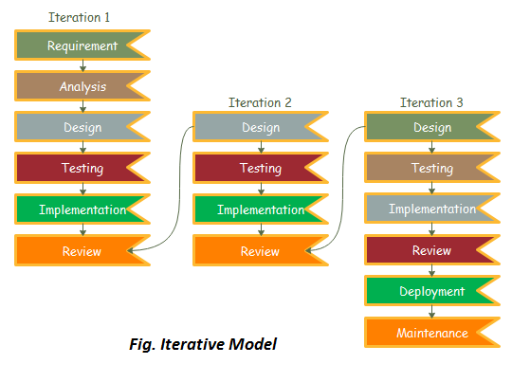

Figure : Iterative model of software development life cycle

### REQUIREMENT PHASE

In this phase, all the necessary requirements are analysed. Till now necessary requirement for further analysis of project is gathered from end-user, Internet and teachers. And as a result, final specification of the project will be gained.

### ANALYSIS AND DESIGN PHASE

In this phase, the specification gathered is designed as per the requirement. Further the database models, technical requirement and the logic will be implemented in the project.

### IMPLEMENTATION

After the analysis and design the coding is done according to the specifications. Coding is in progress and hence a working system will be obtained in this phase.

### TESTING

Once a system is developed series of testing will be performed in order to remove bugs and errors. Also, in this phase certain changes, if necessary, will also be applied to obtain complete and successful system.

### EVALUATION

Evaluation is the last step performed after all the prior steps, where the project will be evaluated to check if it meets the specification or not.

## WHY ITERATIVE MODEL?

Requirements can be changed if necessary by going back to the previous phases without any effect to the further ongoing process.

## TOOLS USED

|  |  |
| --- | --- |
| TOOLS | PURPOSE |
| Python | Whole application base creation platform |
| GitHub | To manage Source Code |
| Django | Framework of Python used to create web applications. |
| Android device | For Testing |

Table 1: Tools used

## TECHNOLOGIES

* Operating system: Windows 8/10/11.
* Python Programming language.
* Django framework for the development of backend.
* HTML, CSS, JS.
* Sqlite3, for database.
* Web Browser.

# **WORK DIVISION**

|  |  |  |  |
| --- | --- | --- | --- |
| SN | NAME | ROLES | RESPONSIBILITIES |
| 1 | Mandeep Panta. | System/Back-end developer | * Test System Interfaces * Define and execute development requirements * Develop, maintain and implement policies and procedures necessary to ensure the security and integrity of the corporate database * Develop website |
| 2 | Abhinav Paudel | Front-end Developer  And UI Designer | * Develop Use-Friendly Interface and work through design revisions * Evaluating existing applications and performing updates and modifications * Develop Use-Friendly Interface and work through design revisions. |
| 3 | Ashbin Thapa | Project Manager  Documentation | * Review and approve all project deliverables * Day to Day responsibility to keep project on track for the successful delivery of Study Room System. * Develop Documentation |

Table 2: Work Divisions

# **PROJECT DELIVERABLES**

The website is our major part of development. The website is user friendly, clean functioning and in accordance with the latest technology. The website will have sorting algorithm integrated for rating of answers to the questions.

User profile management: Users will be able to manage their profiles, including updating their personal information. Overall, the primary goal of a question-answer web application is to provide a user-friendly and efficient platform for users to ask and answer questions, share knowledge and information, and engage with a community of like-minded individuals.

# **PROJECT TASK AND TIME SCHEDULE**

The project schedule has been designed as per requirements of the project. Various tasks have been enlisted in the table as per the requirements. Debugging and testing is to be done prior to the completion of the project. Similarly, approximate duration has been scheduled as per the tasks.

|  |  |
| --- | --- |
| **TASK** | **APPROX** **DURATION IN DAYS** |
|  |  |
| Requirements analysis and specification | 7 |
|  |  |
| Under take analysis of the system | 8 |
|  |  |
| Design system | 14 |
|  |  |
| Produce Requirements specification | 9 |
|  |  |
| Testing and debugging | 8 |
|  |  |
| Test system modules | 4 |
|  |  |
| Overall system test | 5 |
|  |  |
| Develop Documents | 4 |
|  |  |

Table 3: Project Task and Time Schedule

## GANTT CHART

The Gantt chart below has been constructed on the basis of the above project schedule. According to the table the project is estimated to be completed in 3 months. The task is started from preliminary investigations and the other tasks are scheduled in accordance.

|  |  |  |  |  |  |
| --- | --- | --- | --- | --- | --- |
| Month  Task | Feb 2023 | Feb 2023 | March 2023 | March 2023 | April 2023 |
| Requirement Analysis |  |  |  |  |  |
| Analysis of the System |  |  |  |  |  |
| Design System |  |  |  |  |  |
| Procedure Requirement and Coding |  |  |  |  |  |
| Testing and Debugging |  |  |  |  |  |
| Test System Modules |  |  |  |  |  |
| Overall System Test |  |  |  |  |  |
| Develop Documentation |  |  |  |  |  |

Figure 2: Gantt Chart

# **REQUIREMENT ANALYSIS**

Requirement analysis, in software engineering encompasses those tasks that go into determining the need and conditions to meet for a new or altered product, taking account of possibly conflicting requirements of the various stakeholders, such as beneficiaries and users. It is the early-stage activity of requirement engineering which consist all the activities with eliciting, analyzing, documenting, validating, and managing requirements.

## FUNCTIONAL REQUIREMENTS

|  |  |  |
| --- | --- | --- |
| S.N. | Requirements | Priority |
| 1 | User interface for the users to view questions and answers | High |
| 2 | User is able to create questions and answers | Essential |
| 3 | User is able to sign in to view question details | High |
| 4 | User is able to sign out from the module | Optional |
| 5 | User must be logged in to create a post | Essential |
| 6 | User can manage their own profile | Optional |
| 7 | User can’t connect without internet | Essential |
| 8 | User can interact with any questions by activities such as comment, like etc. | High |

Table 4: Functional Requirements

## NON-FUNCTIONAL REQUIREMENTS

|  |  |  |
| --- | --- | --- |
| S. N | Requirements | Priority |
| 1 | The system needs Internet browser for use | Essential |
| 2 | The application should be user friendly | High |
| 3 | The system is implemented using tools specified (Html, CSS, Python, Django, JavaScript, SqlLite3) | Essential |
| 4 | Applications need to operate successfully (or degrade gracefully) within a wide spectrum of operating conditions, such as a range of supported screen resolutions and form factors, network bandwidth situations and network types (2G/3G/4G/Wi-Fi), etc. | High |
| 5 | Application should emphasize on High Performance, High Responsiveness, Good Scalability, Good Usability, High Reliability, Good Security, Modifiability and Maintainability. | High |

Table 5: Non-Functional Requirements

## INPUT REQUIREMENTS

**Source of Data:**

* The information will be given by user themselves and the questions have to full-filled detailed about related topics.

**Data Required:**

* User Information

This contains user’s full name, username, email, password and address.

* Questions

This contains the question’s details (Post Name, Date, Time, Description, Topic) input by the user.

## OUTPUT REQUIREMENTS

Output Objectives: The user requires following output from our system

* Answers on the question asked in the Question post.
* Full detail on the questions they have asked and questions they have answered to
* Topic recommendation based on user’s past and consumption data and pattern

## SECURITY REQUIREMENTS

Users are to sign up and then only get access to the information regarding the question blogs so that each user can have their separate record of topics they are interested in or answered to and only authorized user will be able to update the blog post. Therefore, each user has been given their own account with username and password to login. Password are saved in database, which are hashed using Sha-1 protocol. This will keep the information safe from intruders as well as those who are authorized to manage database only.

# **SYSTEM DESIGN AND UML DIAGRAM**

Designing according to the requirement specification, we have tried to make sure that the system actually confirms the user requirements of the system.

## SYSTEM ARCHITECTURE

The system generally revolves around 3 groups of user- question blog creator, answering user and the group of viewers. The general interaction between them is through this system in the following way.

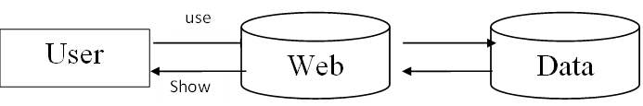

Figure 3: System Architecture

All the question blog creators can create an account and insert the details of the question according to the category of topic. The other user can check the questions and add their own questions too.

The users who want to view or answer the questions can register through this site. The registered questions can be altered i.e. can be modified according to the needs.

## ER DIAGRAM

The ER Diagram is a pictorial representation of the overall logical structure of the system’s database. The ER Diagram of our system is given below. It shows the relationship among the five entities of our system. The entities are represented in the rectangle, their attributes are represented in the oval and the attributes that are underlined are the primary keys.

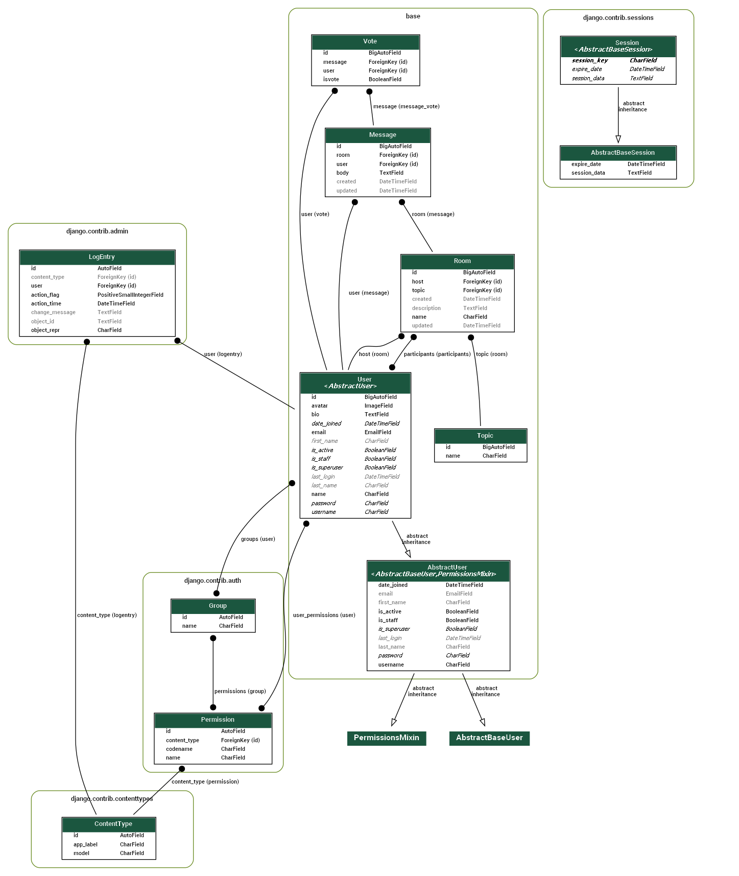

Figure 4: ER Diagram

## USE CASE DIAGRAM

A use case diagram at its simplest is a representation of a user's interaction with the system that shows the relationship between the user and the different use cases in which the user is involved. The actors for our system are: User and System. The simplified and graphical representation of what our system must actually do is represented below:

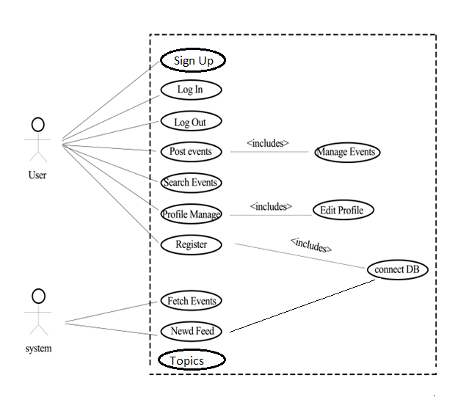

Figure 5: Use Case Diagram

## CLASS DIAGRAM

A class diagram in the Unified Modeling Language (UML) is a type of static structure diagram that describes the structure of a system. We designed the following class diagram to illustrate the system's classes, their attributes, operations (or methods), and the relationships among objects.

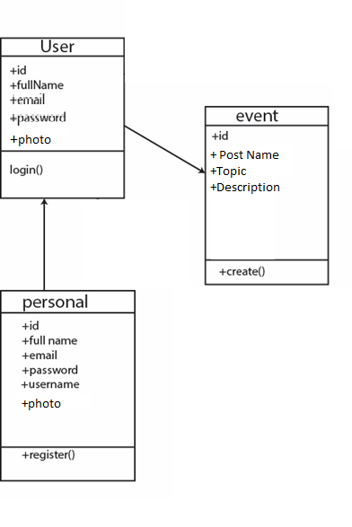

Figure 6: Class Diagram

## DATA FLOW DIAGRAM

A data flow diagram (DFD) is a graphical representation of the "flow" of data through an information system, modelling its process aspects. We used DFD as a preliminary step to create an overview of the system, which can later be elaborated also be used for the visualization of data processing (structured design).

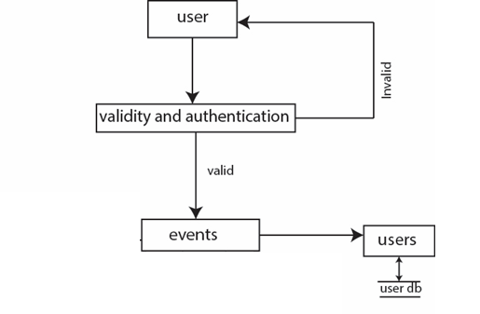

Figure 7: Data Flow Diagram

## CONTEXT DIAGRAM

The overall explanation of a system is represented by a context diagram. Using this diagram, we define the boundary between the system, or part of a system, and its environment, showing the entities that interact with it. The diagrammatic representation of Study Room context diagram is below:

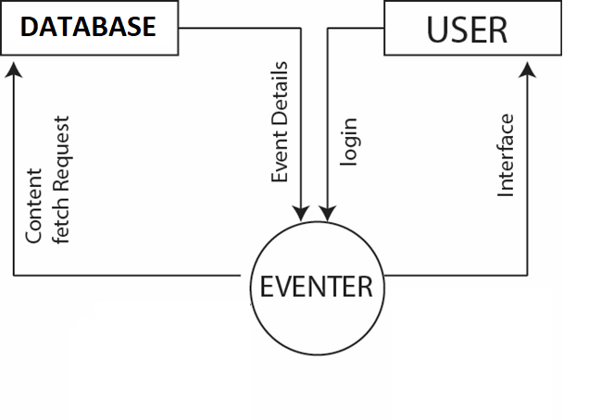

Figure 8: Context Diagram

## SEQUENCE DIAGRAM

Sequence Diagram is an interaction diagram. It shows how the events occur and in what order. For our system we have designed sequence diagrams for most critical and influential activities which are shown below:

## SEQUENCE DIAGRAM FOR REGISTER

The sequence diagram for a new user to register is represented as below. The user may choose to sign via manually to register his/her details.

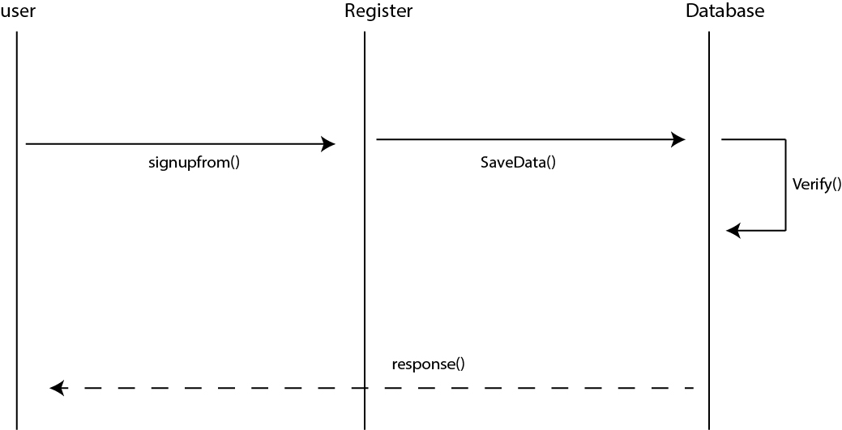

Figure 9: Sequence Diagram for Register

## SEQUENCE DIAGRAM FOR LOGIN

The Sequence Diagram for depicting Login Activity for user is represented below:

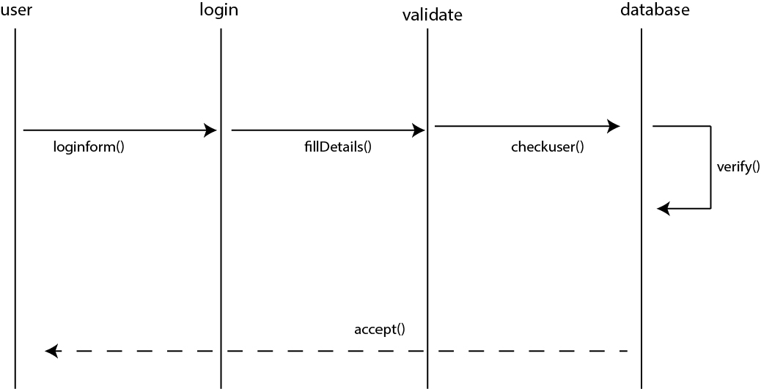

Figure 10: Sequence Diagram for Login

## SEQUENCE DIAGRAM FOR LOGOUT

The Sequence Diagram for Logout Activity of user is represented as following:

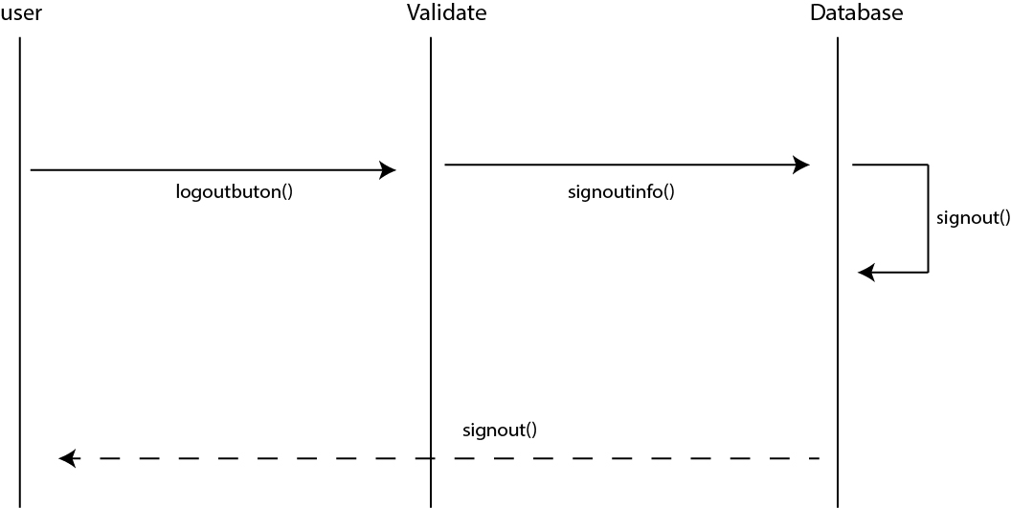

Figure 11: Sequence Diagram for Logout

## SEQUENCE DIAGRAM FOR EVENT

The sequence diagram for any event is below:

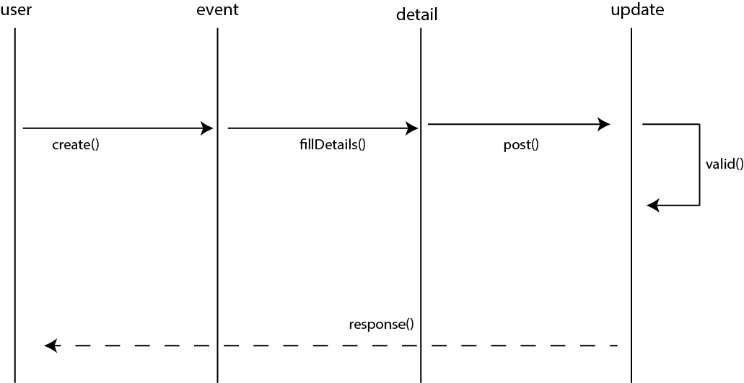

Figure 12: Sequence Diagram for Event

# **PROJECT TESTING**

All the elements of the developed worked must be functioned properly. For this we created a test cases for our work, in which elements such as validation, reliability and user acceptance will be tested.

**Testing Table**

|  |  |  |  |  |  |  |
| --- | --- | --- | --- | --- | --- | --- |
| **Test**  **No.** | **Unit** | **Test** | **Expected**  **Result** | **Test**  **Outcome** | **Evidence** | **If**  **Failure** |
| **1** | Sign Up | Check whether a new account can be created on filling up required details | Account Successfully created | Successful | Test: 1 |  |
| **2** | Login | Check login credentials for valid email and password | User is successfully logged in | Successful | Test: 2 |  |
| **3** | Create and Update Post | Check whether the Post created and updated are successfully registered or not. | Post is successfully Created and Updated | Successful | Test:3 |  |

Table 6: Project Testing Table

**TEST EVIDENCES**

**TEST 1:**

Unit: Sign Up

Purpose: Check whether a new account can be created on filling up required details.

Expected Output: Account Successfully Created

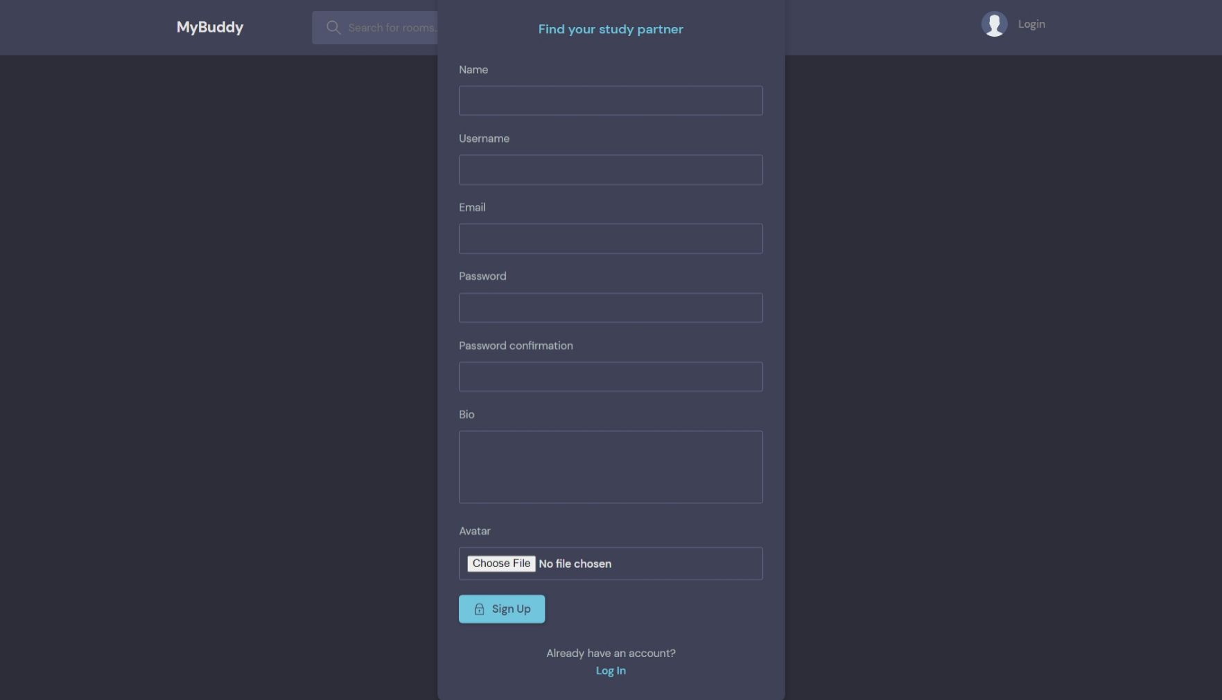

**TEST 2:**

Unit: Login

Purpose: Check Login credentials for valid email and password

Expected Output: User is successfully logged in

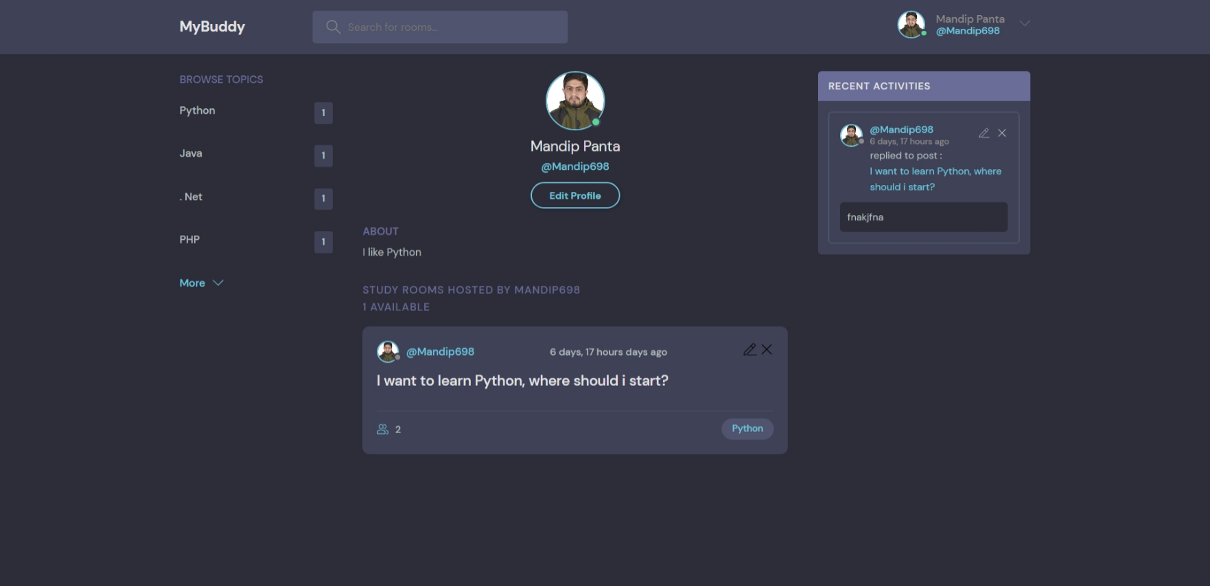

**TEST 3:**

Unit: Create Post

Purpose: To know what happens if all the required field/s are filled correctly by user

Input: All required fields were properly filled

Expected Output: Room is successfully created.

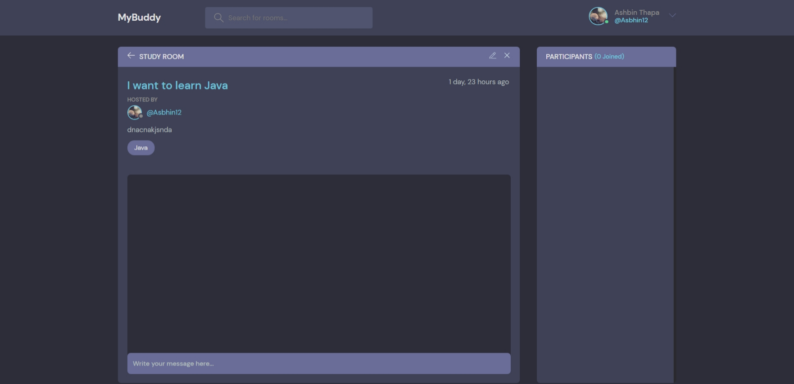

# **CONCLUSION AND FUTURE WORKS**

Our system **“STUDY ROOM”** is now at initial phase with its beta version having most of the basic functionalities discussed before. All the modules have been working after integrating and are ready for the demo. As the features adding up the level of complexity has been increasing as well. However, it is not complete with the ideas we have put through and might need more improvisation in the upcoming days as well. This makes us think about the future extensions that we are going to implement in this system.

The following future extensions will be implemented in our system in upcoming days:

* Sign Up and Login to create posts and give replies.
* Create A Room to post your queries.
* Edit or Delete Your Profile and Posts.
* Agree or Disagree to a Reply, so others can see whether the solution is popular.

# **REFERENCE**

1. [The Python Tutorial — Python 3.10.11 documentation](https://docs.python.org/3.10/tutorial/index.html)
2. [Getting started | Django documentation | Django (djangoproject.com)](https://docs.djangoproject.com/en/4.2/intro/)
3. [HTML Tutorial (w3schools.com)](https://www.w3schools.com/html/)
4. [CSS Tutorial (w3schools.com)](https://www.w3schools.com/css/)
5. [JavaScript Tutorial (w3schools.com)](https://www.w3schools.com/js/default.asp)
6. YouTube Python and Django Tutorials “www.youtube.com”
7. “UML design “ <https://www.smartdraw.com/uml-diagram/>

# **APPENDIX**

# Screenshots of developed systems

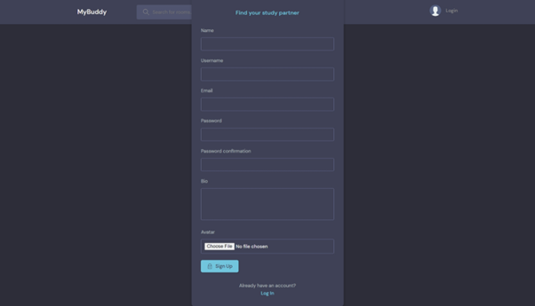

**Figure A.1: Sign Up**

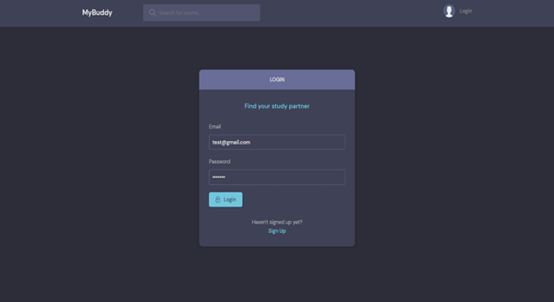

**Figure A.2: Login**

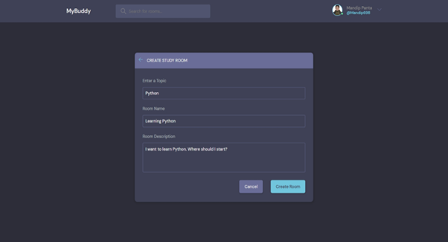

**Figure A.3: Create room or posts**

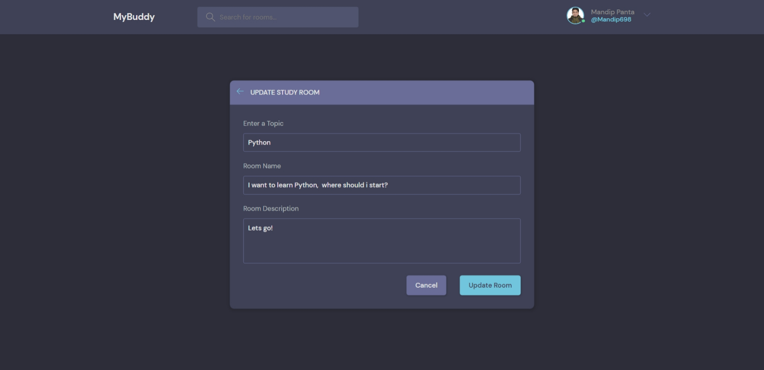

**Figure A.4: Update room or posts**

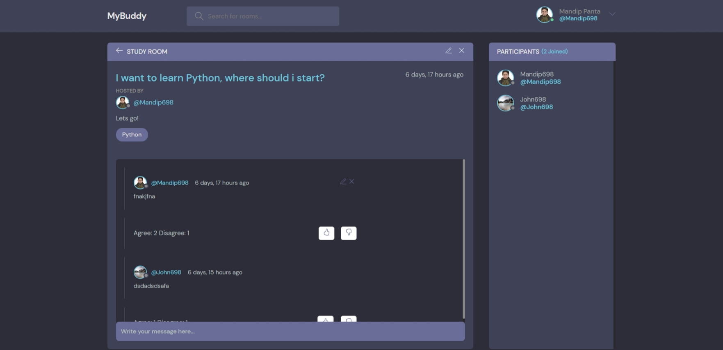

**Figure A.5: Reply or Message**

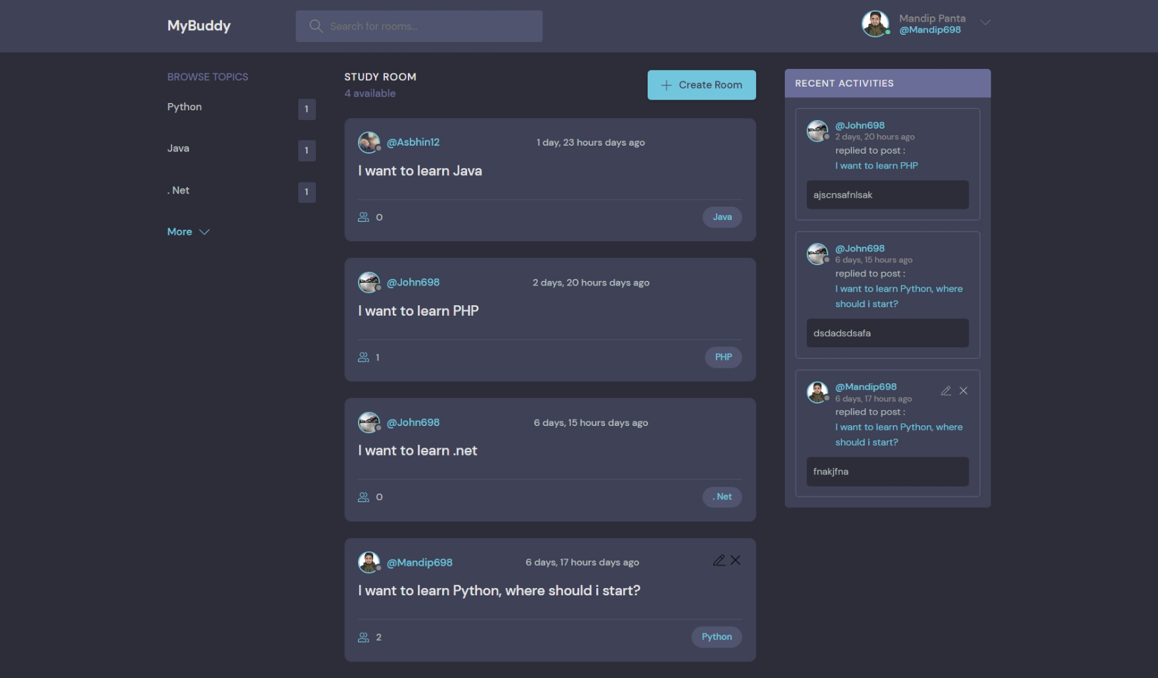

**Figure A.6: Home page**

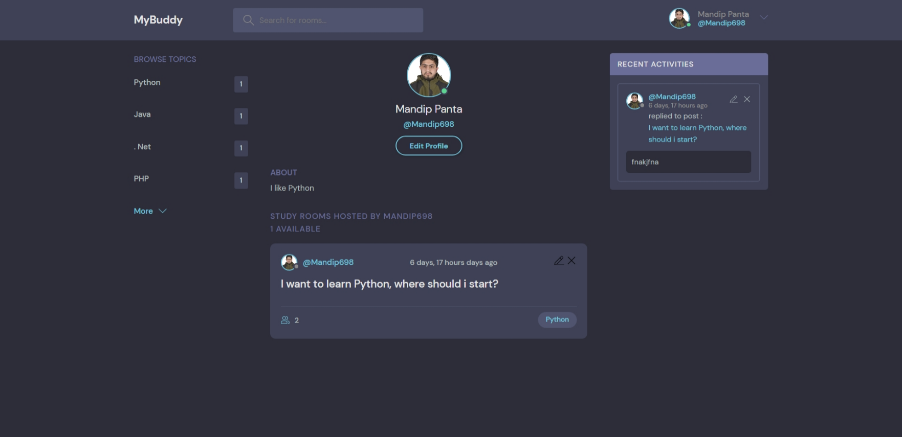

**Figure A.7: User profile**

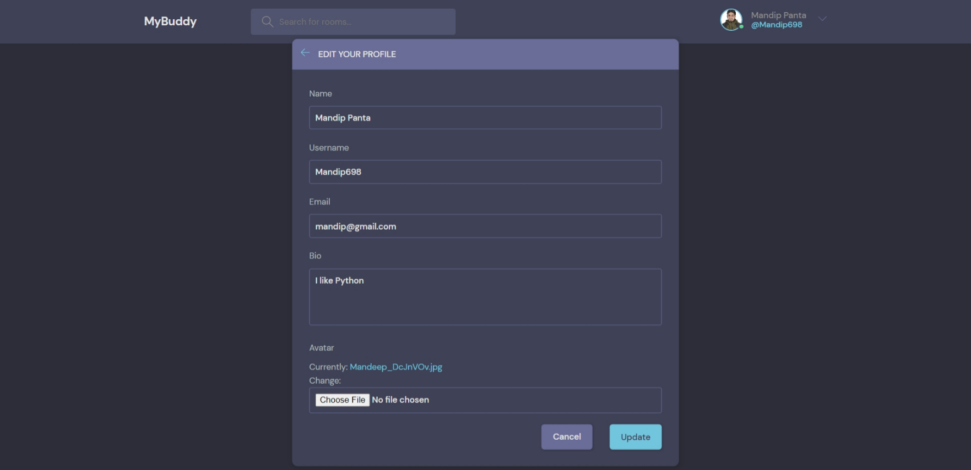

**Figure A.8: User update profile**

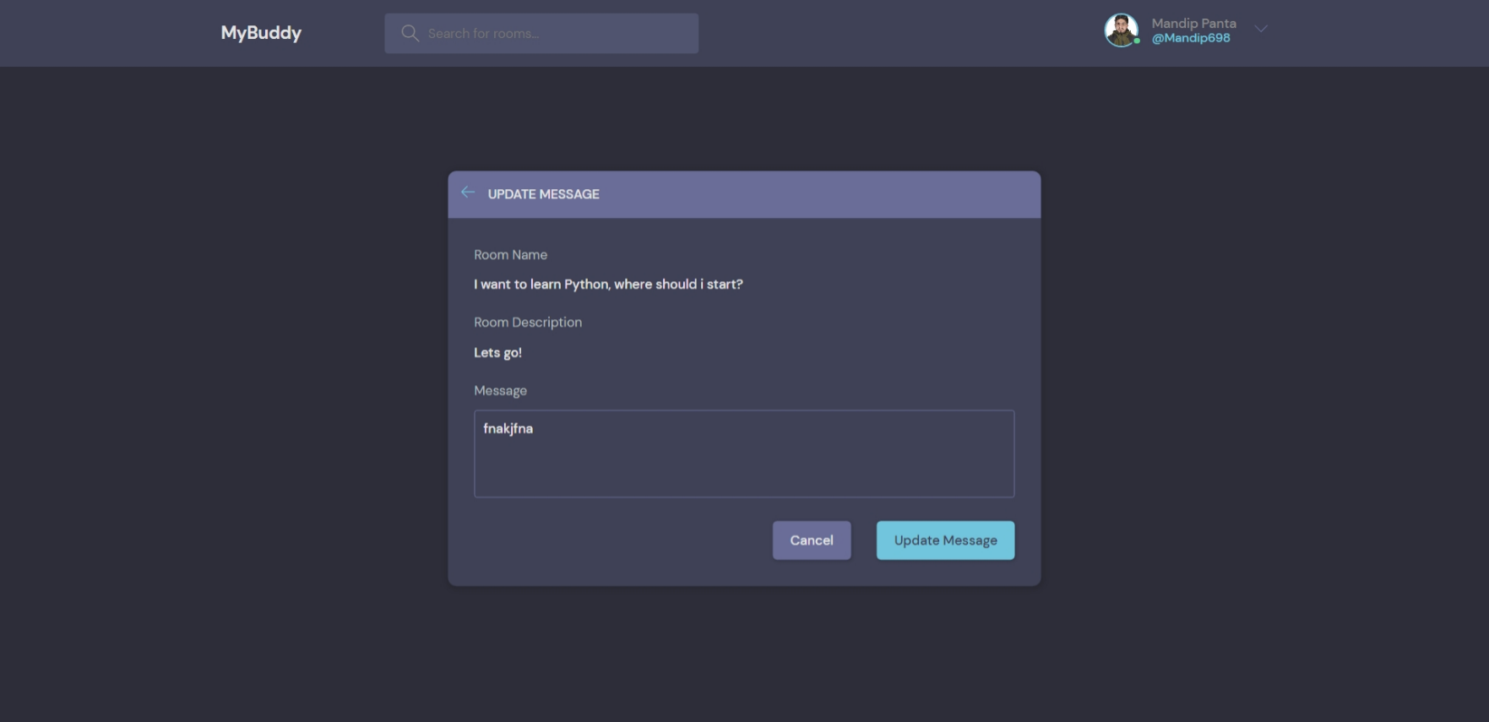

**Figure A.9: Update message or reply**